Project Design Phase-II
Technology Stack (Architecture & Stack)
Date | 14 July 2026
Team ID | ---------------
Project Name | Shopezz - MERN E-Commerce Platform
Maximum Marks | 4 Marks

Technical Architecture
The Shopezz application follows a three-tier MERN architecture. Users access the React frontend, which communicates with Express REST APIs. Node.js processes business logic such as authentication, product management, cart, wishlist, orders and payments. MongoDB Atlas stores application data. The Admin Dashboard accesses secured APIs using JWT authentication.
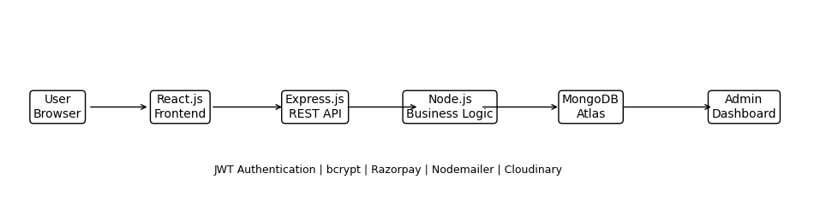

Infrastructure
Frontend: React.js deployed on Vercel
Backend: Node.js + Express deployed on Render
Database: MongoDB Atlas
Authentication: JWT + bcrypt
Payment: Razorpay/Stripe
Image Storage: Cloudinary (optional)
Email Service: Nodemailer

Components & Technologies
Component | Description | Technology
Frontend | Customer/Admin UI | React.js, HTML5, CSS3, Bootstrap
Backend | REST APIs | Node.js, Express.js
Authentication | Secure Login | JWT, bcrypt
Database | Products, Users, Orders | MongoDB Atlas
Payment | Online Payments | Razorpay / Stripe
Deployment | Hosting | Vercel + Render

Application Characteristics
Characteristic | Description | Technology
Open Source | Frameworks | React, Express, Node, MongoDB
Security | Encrypted passwords & tokens | bcrypt, JWT, HTTPS
Scalability | Three-tier architecture | REST API + MongoDB
Availability | Cloud deployment | Vercel, Render, Atlas
Performance | Optimized API & DB | Indexes, Async operations

